VCQI Routine Immunization (RI) Demonstration Datasets – District #20
The files in this folder hold simulated (fake, faux) survey responses from a routine immunization vaccination coverage survey conducted in a fictional health district named District #20. The survey design is the classic World Health Organization Expanded Programme on Immunization 30 clusters by 7 respondents per cluster. The data are self-weighted, which is to say that every survey respondent carries the same survey weight.
The doses in the survey are the classic eight EPI doses: BCG, OPV1-3, Penta1-3, and MCV. The doses are due at:
Dose | Due at age:
BCG | birth
OPV1 & Penta1 | 8 weeks
OPV2 & Penta2 | 12 weeks
OPV3 & Penta3 | 16 weeks
MCV | 9 months
Children were eligible for this survey if they were born between January 1, 2015 and December 31, 2015 (inclusive). The dataset is simulated so although the vaccination dates are somewhat realistic, all the children were born on January 1, 2015 and all the interviews were conducted on January 1, 2017.
The survey includes vaccination evidence from home-based vaccination records (HBRs or cards) only. Because every child presented a vaccination card, and none of the caregivers suggested that the child had received doses that were not recorded on the card, the only interesting source of evidence in this dataset is what was recorded from the cards.
These files serve as inputs for learning VCQI and may be analyzed using a demo VCQI control program that has already been adapted to work with this data. You will find instructions in the document named Getting Started with VCQI which is available on the VCQI Resources website.
Challenges:
- Follow instructions in the Getting Started manual to conduct a basic analysis.
- Modify the control program to add child sex as a stratifying variable so VCQI will produce indicator outcomes for both boys and girls.
- Select an outcome that appears to differ, like crude coverage of measles, and use the COVG_DIFF indicator to formally test the hypothesis that the difference between coverage for boys and girls is statistically significant. Present the difference in an English language sentence.
- Write down a list of assumptions and caveats that should accompany the presentation of the hypothesis test and its results.
Contact Dale Rhoda at Biostat Global Consulting (Dale.Rhoda@biostatglobal.com) with questions.

The timeliness of the vaccinations may be observed with these cumulative coverage curves. A very small number of doses were administered early and most doses were received within four weeks of the age when they are scheduled.
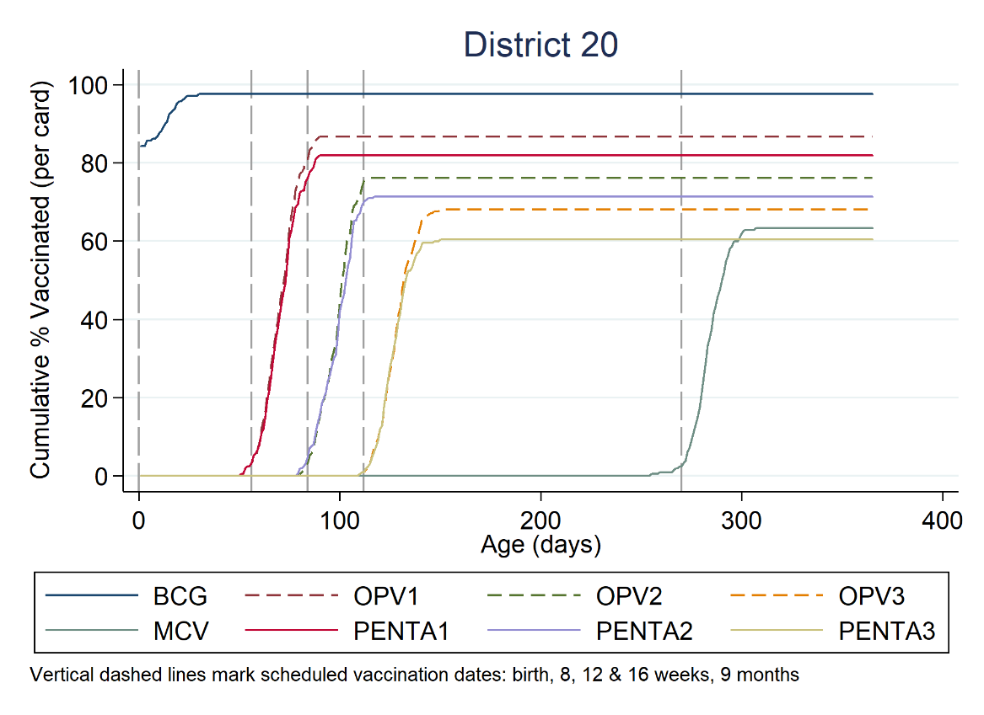

Timeliness may also be summarized with VCQI’s coverage and timeliness chart. The figure below categorizes the portion of children that were vaccinated early, in a timely manner, and several categories of late. In this dataset, all the late dose were received within two months of the target age. A very small number of doses appear in the light pink ‘Timing Unknown’ category which means they were recorded with a tick mark or with a date that failed a data quality check (i.e., a partial date; illegible date; full date that fell outside the expected time window; two consecutive doses were recorded with the same date; or the dates for doses in a series were not in chronological order)
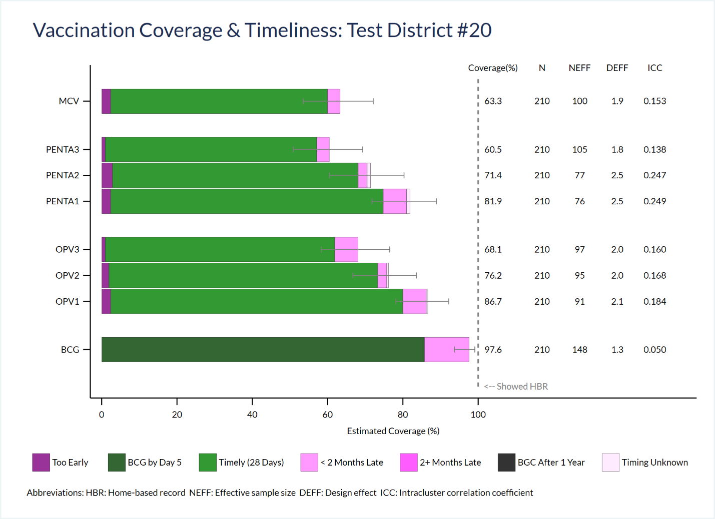

There is a notable dose-by-dose difference between coverage among boys and girls in this dataset as seen here:
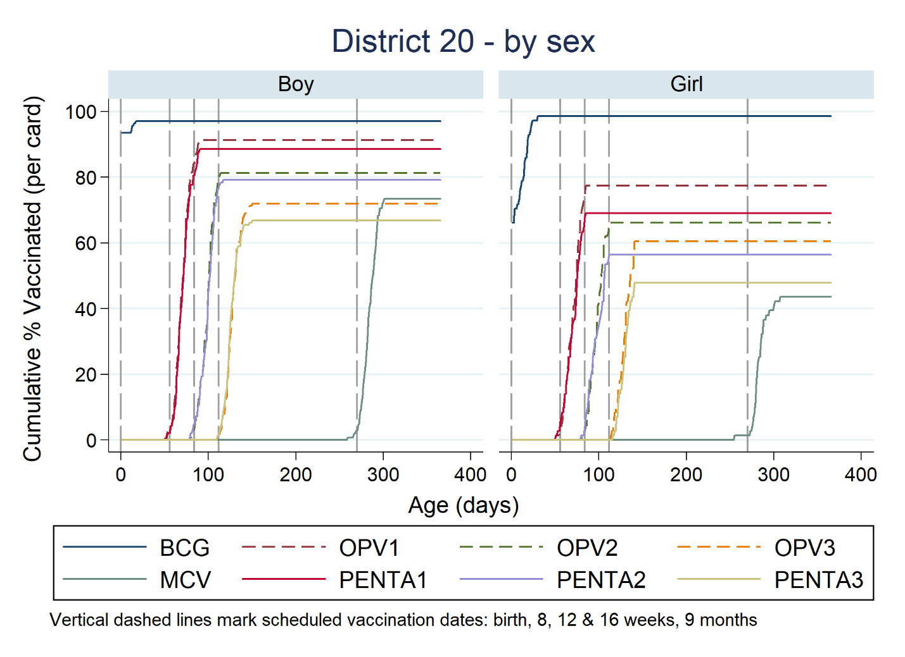

http://www.biostatglobal.com/VCQI_RESOURCES.html

